

|  |
| --- |
| Web Development with HTML5 and CSS assignment Report |

|  |  |
| --- | --- |
| The work of | Sarah Al Kooheji@00574388 |

|  |
| --- |
| Table of contents |

1.site content and design

Website Url <https://sarahalkooheji.github.io/SarahsArtSupplies/>

For my Website I have decided to create an online shopping store, the online store sells and offers art supplies to the customers.

The website’s layout is fluid because I have used % in the sizes so that it can adapt to all the sizes with no problem,

Website layout for the Home page

Nav bar

Website logo

product

product

product

product

product

product

product

product

product

Nav bar

Website logo

product

product

product

Website page for products

header

header

product

product

product

header

product

product

product

About us page cart page

Nav bar

Website logo

image

Nav bar

Website logo

image

socials

Paragraph

Contact number

**Wire frames**

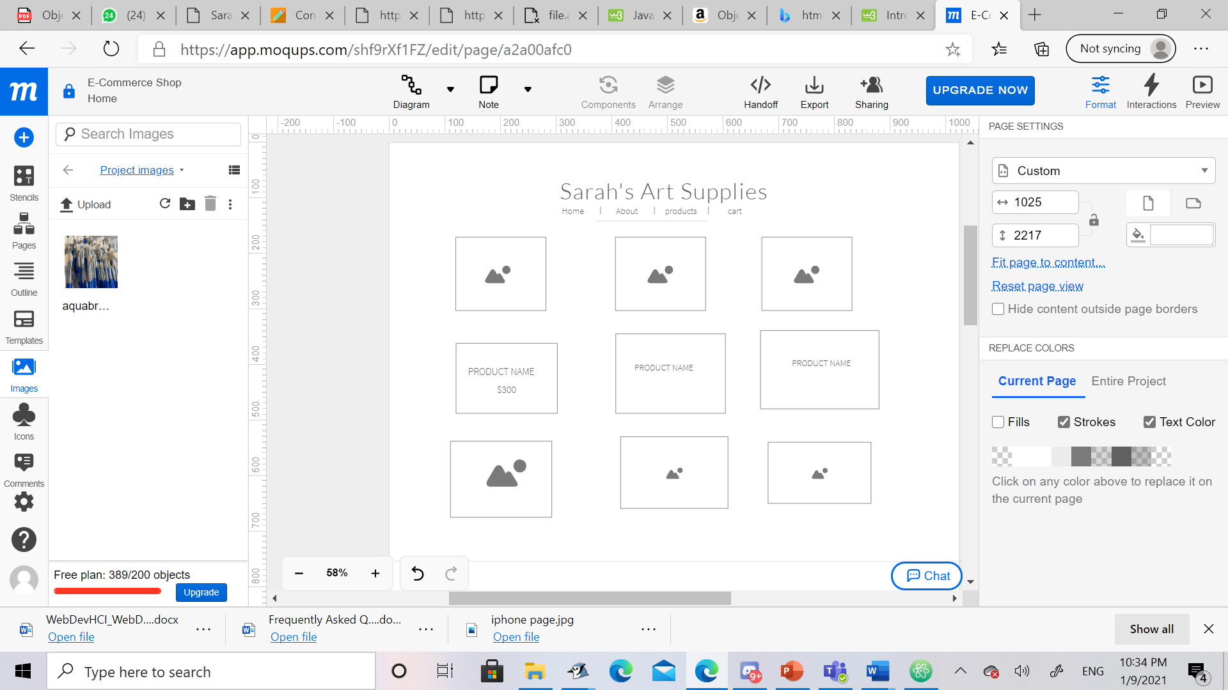

2.Use if HTML5 in home

My home pages consist of various tags with different purposes and properties

**the <head> tag** is where the name of website goes followed by a link to the styles sheet(CSS) and the external link I used for the font in the webpage.

**The <body> tag is where all the work of the website went in.**

The body tag consisted **of many <div> tags** these tags are what sectioned the webpage into different sections for each use.

**The first <div>** was for the header. The header consisted of the title and the nav bar.

tag in the <title> I used a **<span> tag** to change the first word “Sarah’s” in the logo to blue and to make it larger.

In **the second <div>** for the nav bar I used the **<a> tags,** these tags are what links other pages to the home page.

The **third <div>** is what helped create the layout I wanted for my webpage. Which was the grid.

Inside the grid <div> I created many <div>s called item which represented the products.

3.CSS Explanation

My Website Layout is simple and easy to look at. Because I will be displaying large images of the products I didn’t want the viewer to be distracted by the design therefore I chose a white background with blue accents in the texts and images. A minimal design but I have added some intresting animations on the text and images that gave the website a more professional look.

4.CSS Techniques

For the CSS I made two css pages one for all the images and text edits named “styles.css”

The second is for the background color in the pages about us and products named “styles2.css”

Some of the intresting Css techniques that were used were

The colored gradient on the images from : [CSS Gradient — Generator, Maker, and Background](https://cssgradient.io/)

The animations on the images such as scale() and transform() from: [CSS 2D Transforms (w3schools.com)](https://www.w3schools.com/Css/css3_2dtransforms.asp)

Transitions on text from: [transition - CSS: Cascading Style Sheets | MDN (mozilla.org)](https://developer.mozilla.org/en-US/docs/Web/CSS/transition)

5.Graphics and other media

I used in total 4 icons in my website

1.cart icon from: [shopping cart solid icomn - Bing images](https://www.bing.com/images/search?view=detailV2&ccid=4TgEomcG&id=E09BFB1CF31CA76D5F3034C38A1E52EF88F9917B&thid=OIP.4TgEomcGynK8MuSxL4t5twAAAA&mediaurl=https%3a%2f%2fwww.flaticon.com%2fsvg%2fstatic%2ficons%2fsvg%2f711%2f711192.svg&exph=424&expw=424&q=shopping+cart+solid+icomn&simid=607994613177388281&ck=177EB8DBF85924CAC9E50AF9F713ECA8&selectedIndex=1&FORM=IRPRST&ajaxhist=0)

2.twitter icon from: [twitter icon transparent background - twitter logo white circle PNG image with transparent background | TOPpng](https://toppng.com/twitter-icon-transparent-background-twitter-logo-white-circle-PNG-free-PNG-Images_176129)

2.facebook icon from: [Facebook Symbol clipart - Facebook, Circle, transparent clip art (kissclipart.com)](https://www.kissclipart.com/transparent-grey-facebook-icon-clipart-computer-ic-r7v0g3/)

3.instagram icon from: [instagram circle transparent gray - Bing images](https://www.bing.com/images/search?view=detailV2&ccid=LAxmb9iV&id=B50B3290CE6E6535195D8C5E123FAE51D533AF2D&thid=OIP.LAxmb9iVBDEV1GJJgIFCdAHaHa&mediaurl=https%3a%2f%2ftrevoly.com%2fwp-content%2fuploads%2f2018%2f04%2fcircle-instagram.png&exph=512&expw=512&q=instagram+circle+transparent+gray&simid=608051942347836475&ck=5BC0C70C747250E1FFCD1D2066C2869E&selectedIndex=10&FORM=IRPRST&ajaxhist=0)

6.Testing browser

My website is responsive to smaller devices and larger ones. Where images and text doesn’t get cropped

1. 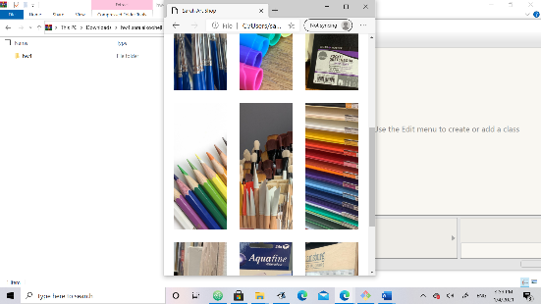On Microsoft edge

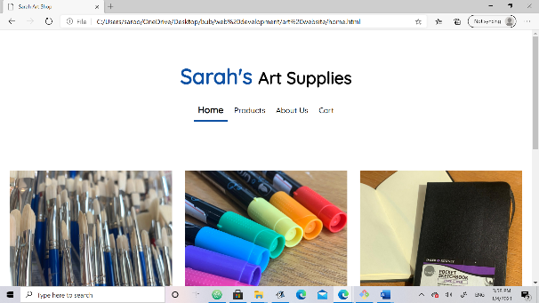

1. On google chrome

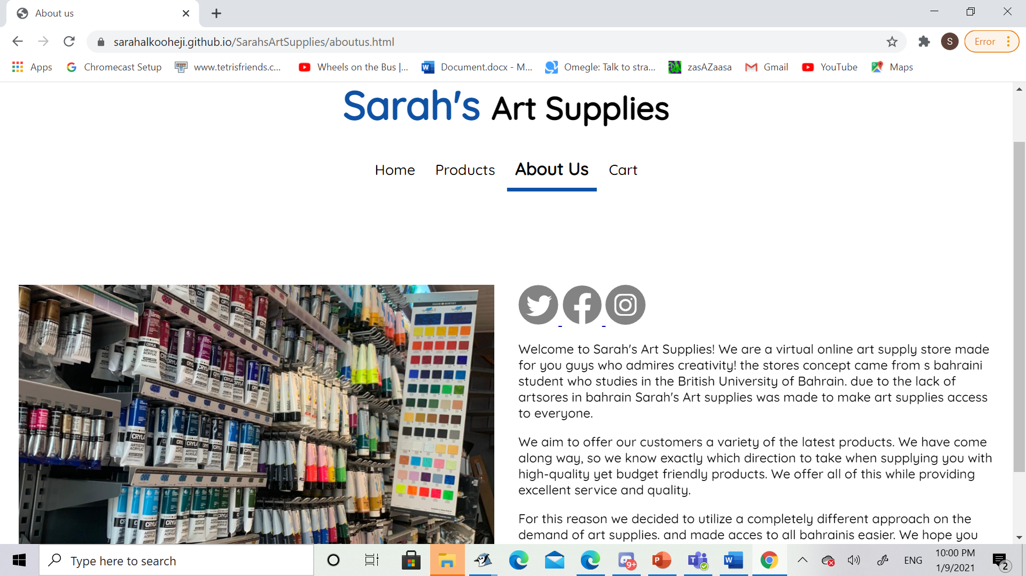

1. A screenshot of a video game

   Description automatically generated with medium confidenceOn I phone Safari browser

7. Validation